

**UNIVERSITY OF PETROLEUM & ENERGY STUDIES**

**Dehradun**

**CONTINOUS INTEGRATION**

**AND**

**CONTINOUS DELIVERY**

**Experiment**

**Name: Rithik Chaudhary**

**Course: B. TECH CSE DevOps (2018-22)**

**Roll no.: R171218084**

**Sapid: 500069261**

**Experiment 10**

**Jenkins Integration with Jenkins**

**Step-1: Start and login to Jenkins**

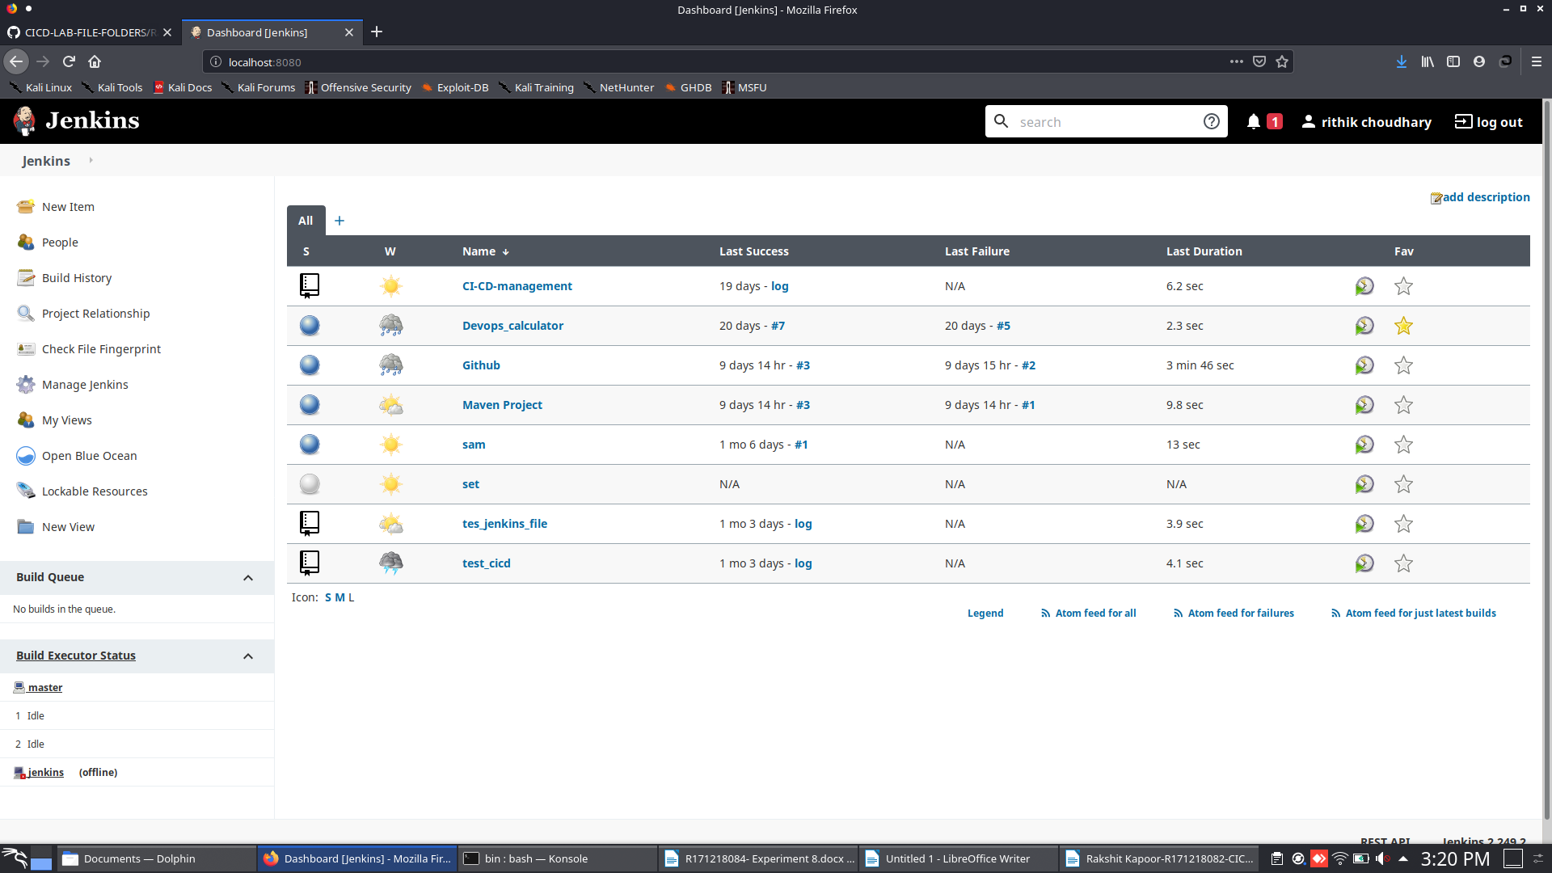

**Step-2: Install nexus plugin**

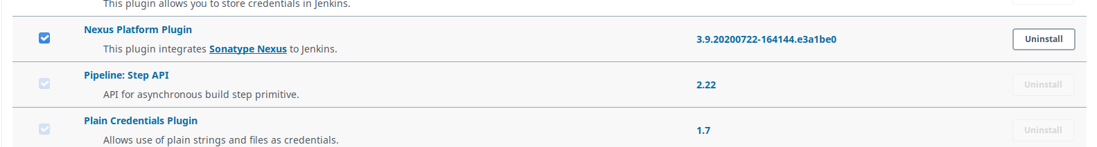

**Step-3: Then go to global tool configuration and provide JDK 8 path**

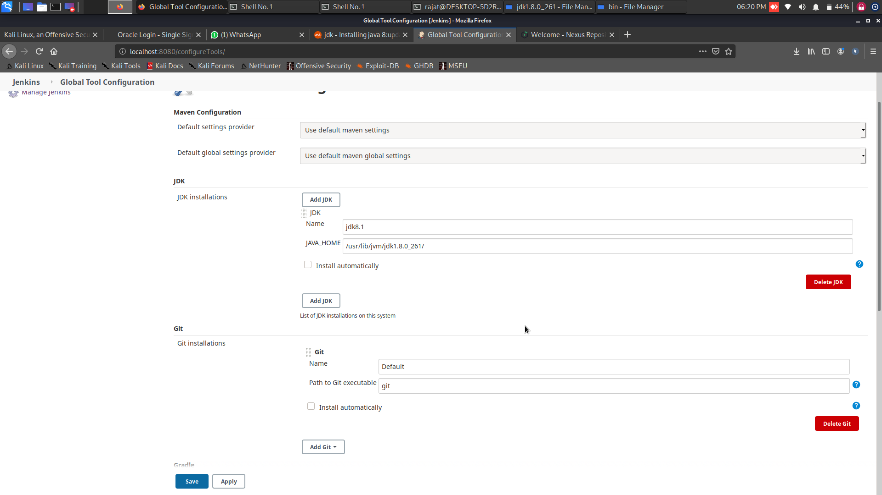

**Step-4: Provide Sonatype nexus details in Configure System**

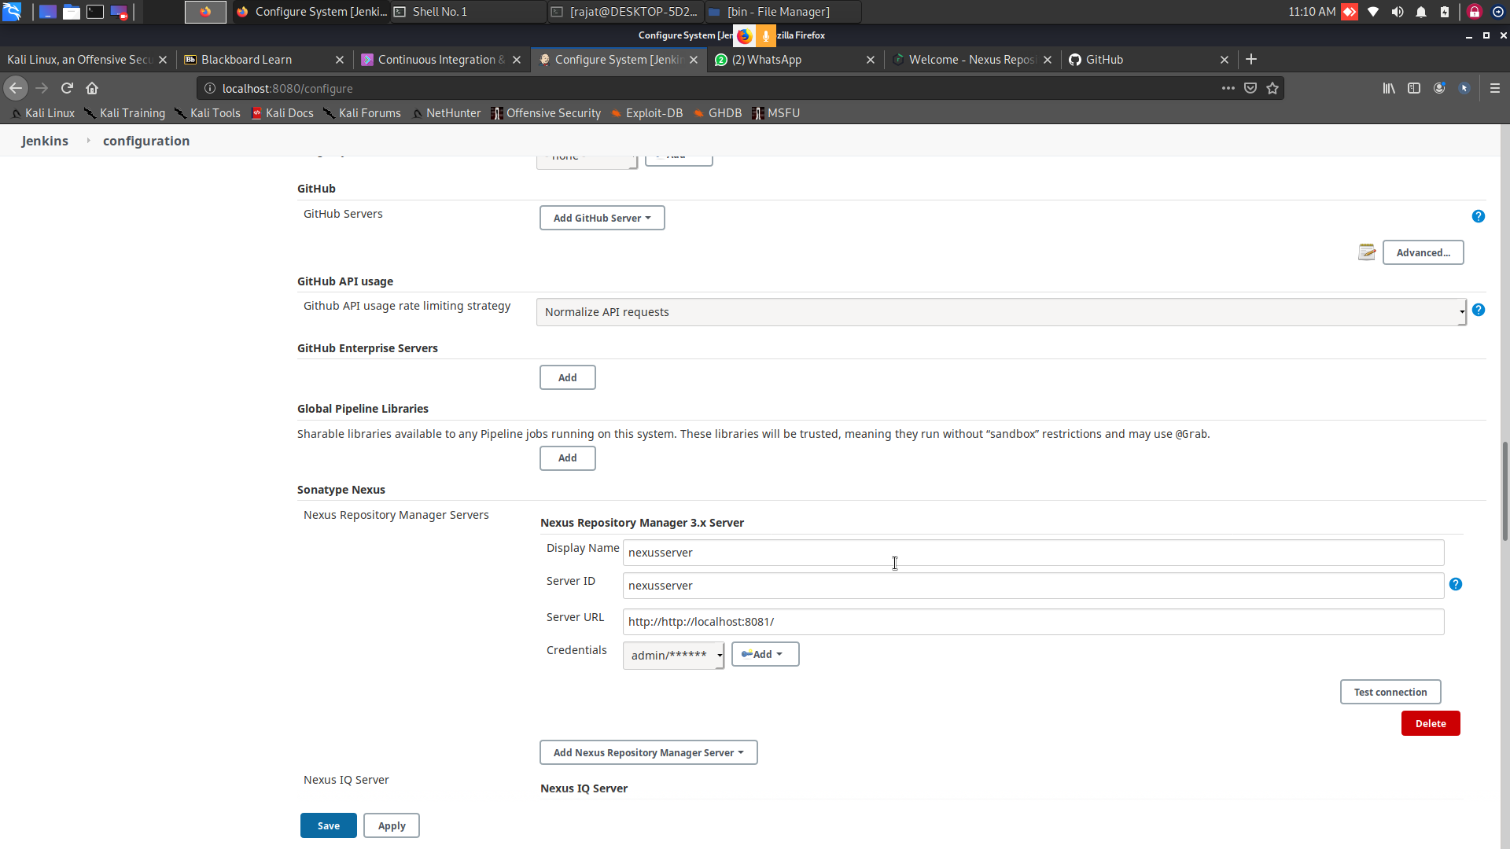

**Step-5: configure maven project pom.xml file**

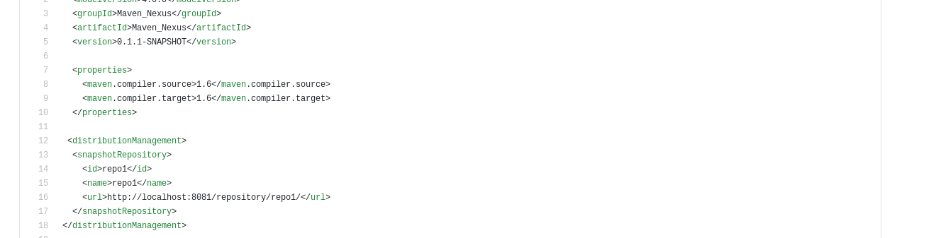

**Step-6: Build your Project**

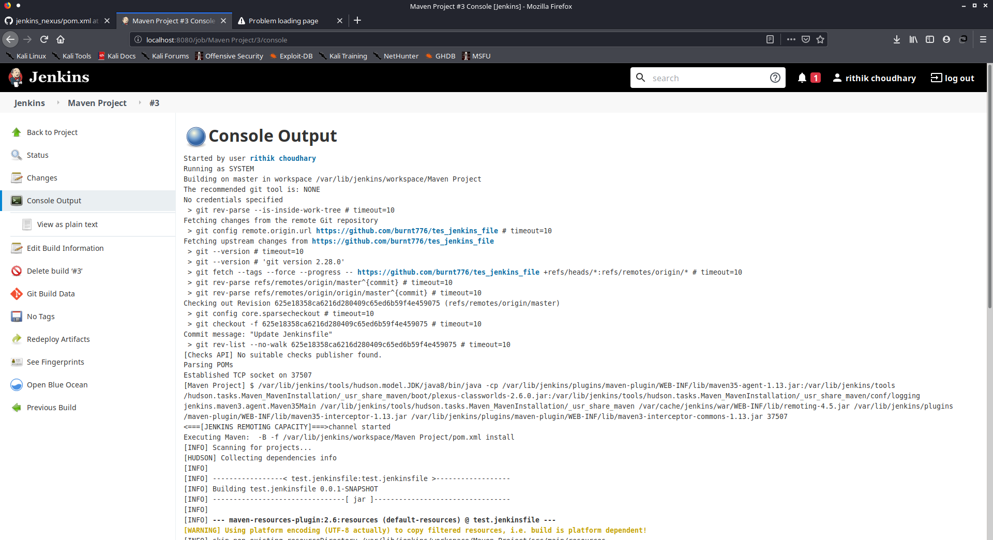

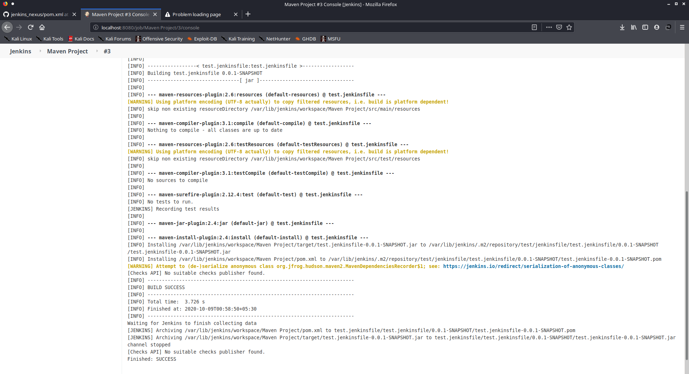

**Step-7: Check nexus for build artifact**

